1.

1. 10000001.00010001.10000001.01100000
2. It ranges from 129.17.129.96 to 129.17.129.127

In dotted decimal: 10000001.00010001.10000001.01100000 to 10000001.00010001.10000001.01111111

1. 129.17.129.96 - 129.17.129.103

129.17.129.104 - 129.17.129.111

129.17.129.112 - 129.17.129.119

129.17.129.120 - 129.17.129.127

2.

|  |  |
| --- | --- |
| Prefix | Outgoing link interface |
| 0000000 | 0 |
| 00000000 00000000 1 | 2 |
| 01010101 | 1 |
| 0101011 | 2 |

3.

|  |  |  |  |  |  |  |
| --- | --- | --- | --- | --- | --- | --- |
| Step | N’ | D(B), P(B) | D(C), P(C) | D(D), P(D) | D(A), P(A) | D(F), P(F) |
| 0 | E | 10,E | INFTY | 4,E | INFTY | 2,E |
| 1 | EF | 6,F | INFTY | 4,E | INFTY | - |
| 2 | EFD | 6,F | 5,C | - | 8,D | - |
| 3 | EFDC | 6,F | - | - | 7,C | - |
| 4 | EFDCB | - | - | - | 7,C | - |
| 5 | EFDCBA | - | - | - | - | - |

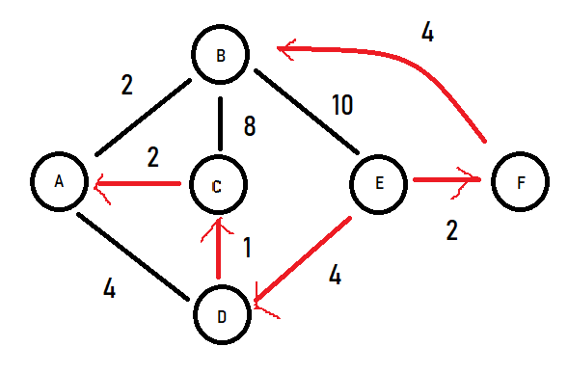

|  |  |
| --- | --- |
| Destination | Link |
| A | (E,D) |
| B | (E,F) |
| C | (E,D) |
| D | (E,D) |
| F | (E,F) |

|  |  |  |  |  |  |  |
| --- | --- | --- | --- | --- | --- | --- |
| Step | N’ | D(E), P(E) | D(C), P(C) | D(D), P(D) | D(A), P(A) | D(F), P(F) |
| 0 | B | 10,B | 8,B | INFTY | 2,B | 4,B |
| 1 | BA | 10,B | 4,A | 6,A | - | 4,B |
| 2 | BAC | 10,B | - | 5,C | - | 4,B |
| 3 | BACF | 6,F | - | 5,C | - | - |
| 4 | BACFD | 6,F | - | - | - | - |
| 5 | BACFDE | - | - | - | - | - |